# **AWS:**

# 

# **Use AWS Marketplace to launch a Wordpress instance and take backups**

Step 1: login to aws management console and navigate to ec2 dashboard.

Step 2: create a new instance .to create a new instance:

* Name the instance
* Go to aws marketplace and search for “wordpress Bitnami” and select the first wordpress AMI.

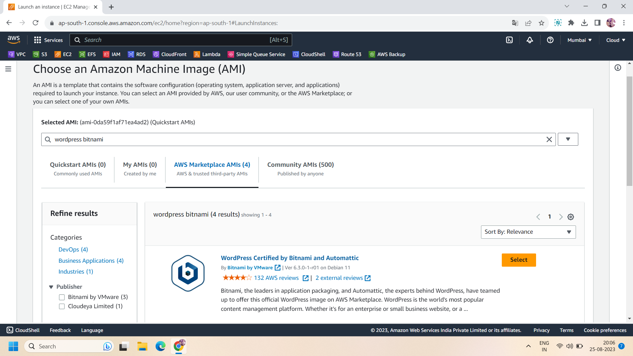

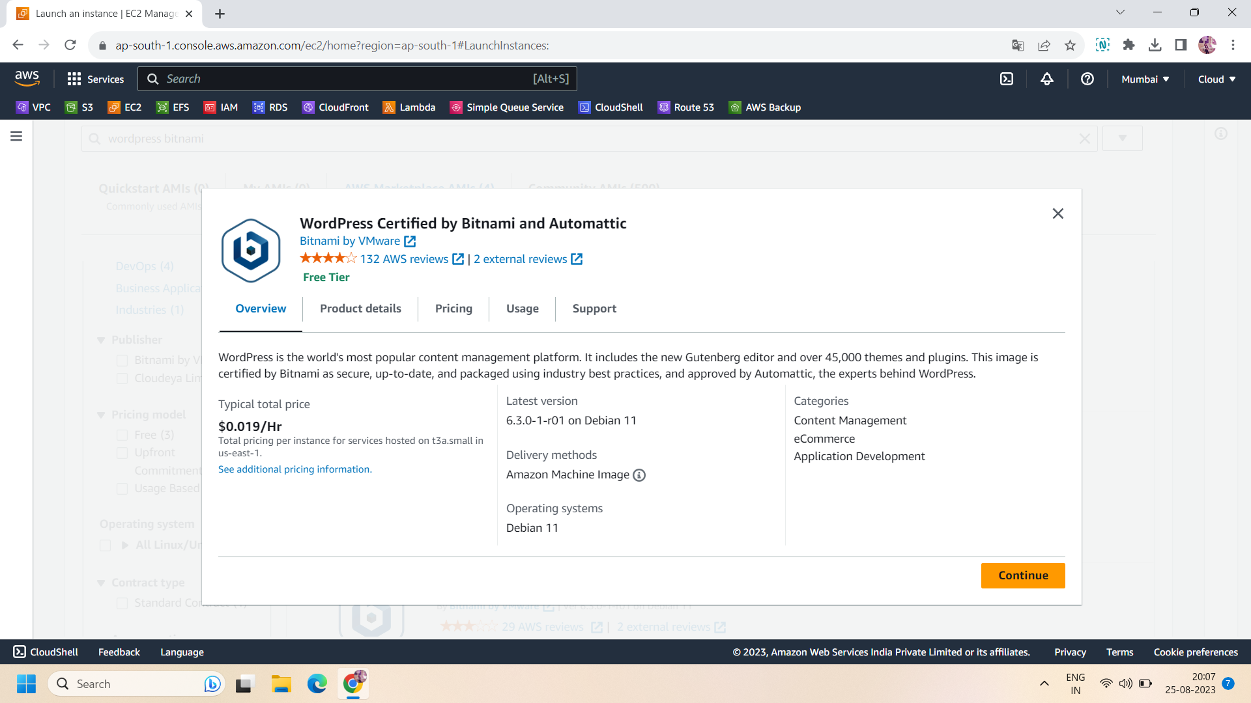

* Rest settings will be default.
* Http and https will be by default added in the security group for wordpress AMI.
* Then click on “launch instance”

Step 3:After creating the wordpress instance,copy the public ip of your instance and go to the browser and paste into it.It will show you ,wordpress default website.

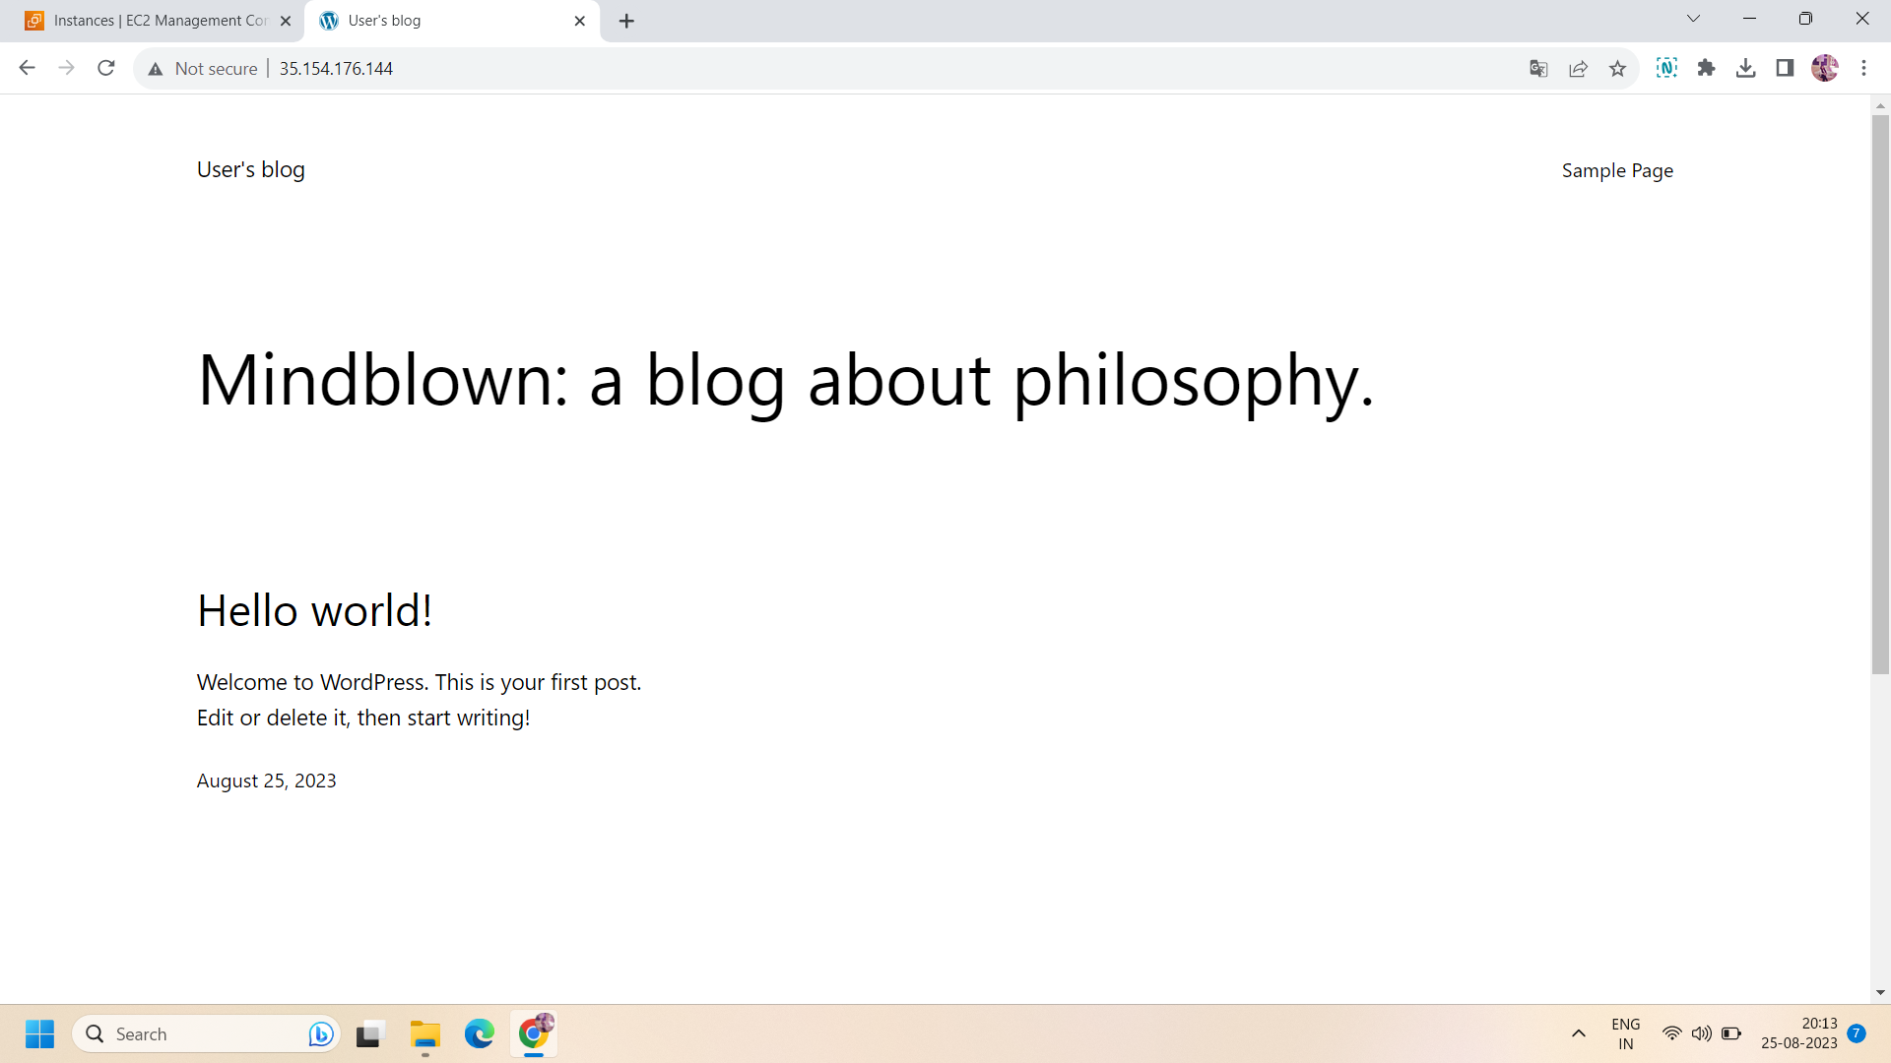

Step 4: The wordpress website we can customize according to our requirements.For any changes ,you have to go to the admin portal of wordpress .For this ,go to the browser and paste your **wordpress instance IP address/admin.**

This will lead to navigating to the admin portal of wordpress.now you need username and password.

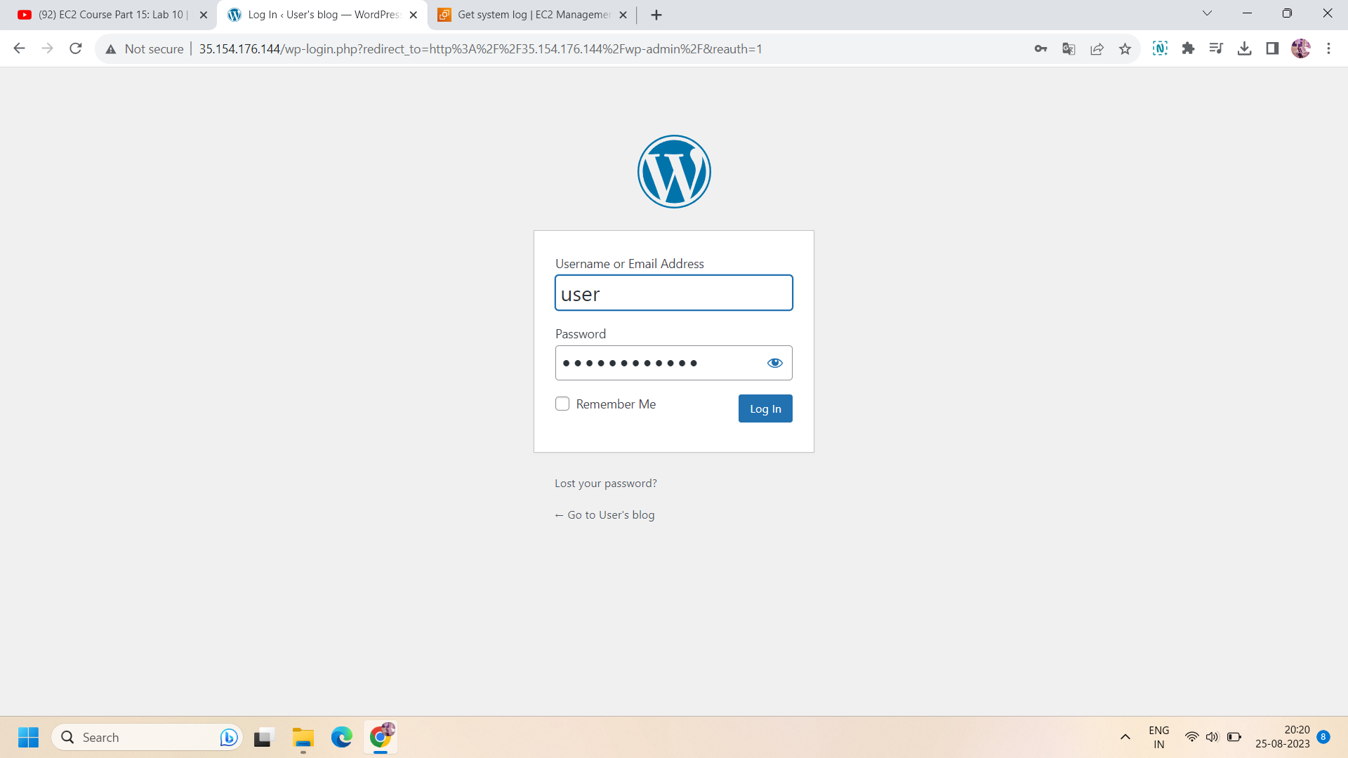

Step 5: for username and password,username will be user and for password,go to ec2 instance,select it and click on actions,in actions go to “monitor and troubleshoot” and click on “get system log”.now in the log file ,the will be password in rectangular box.copy that and paste into admin portal.and login to that.

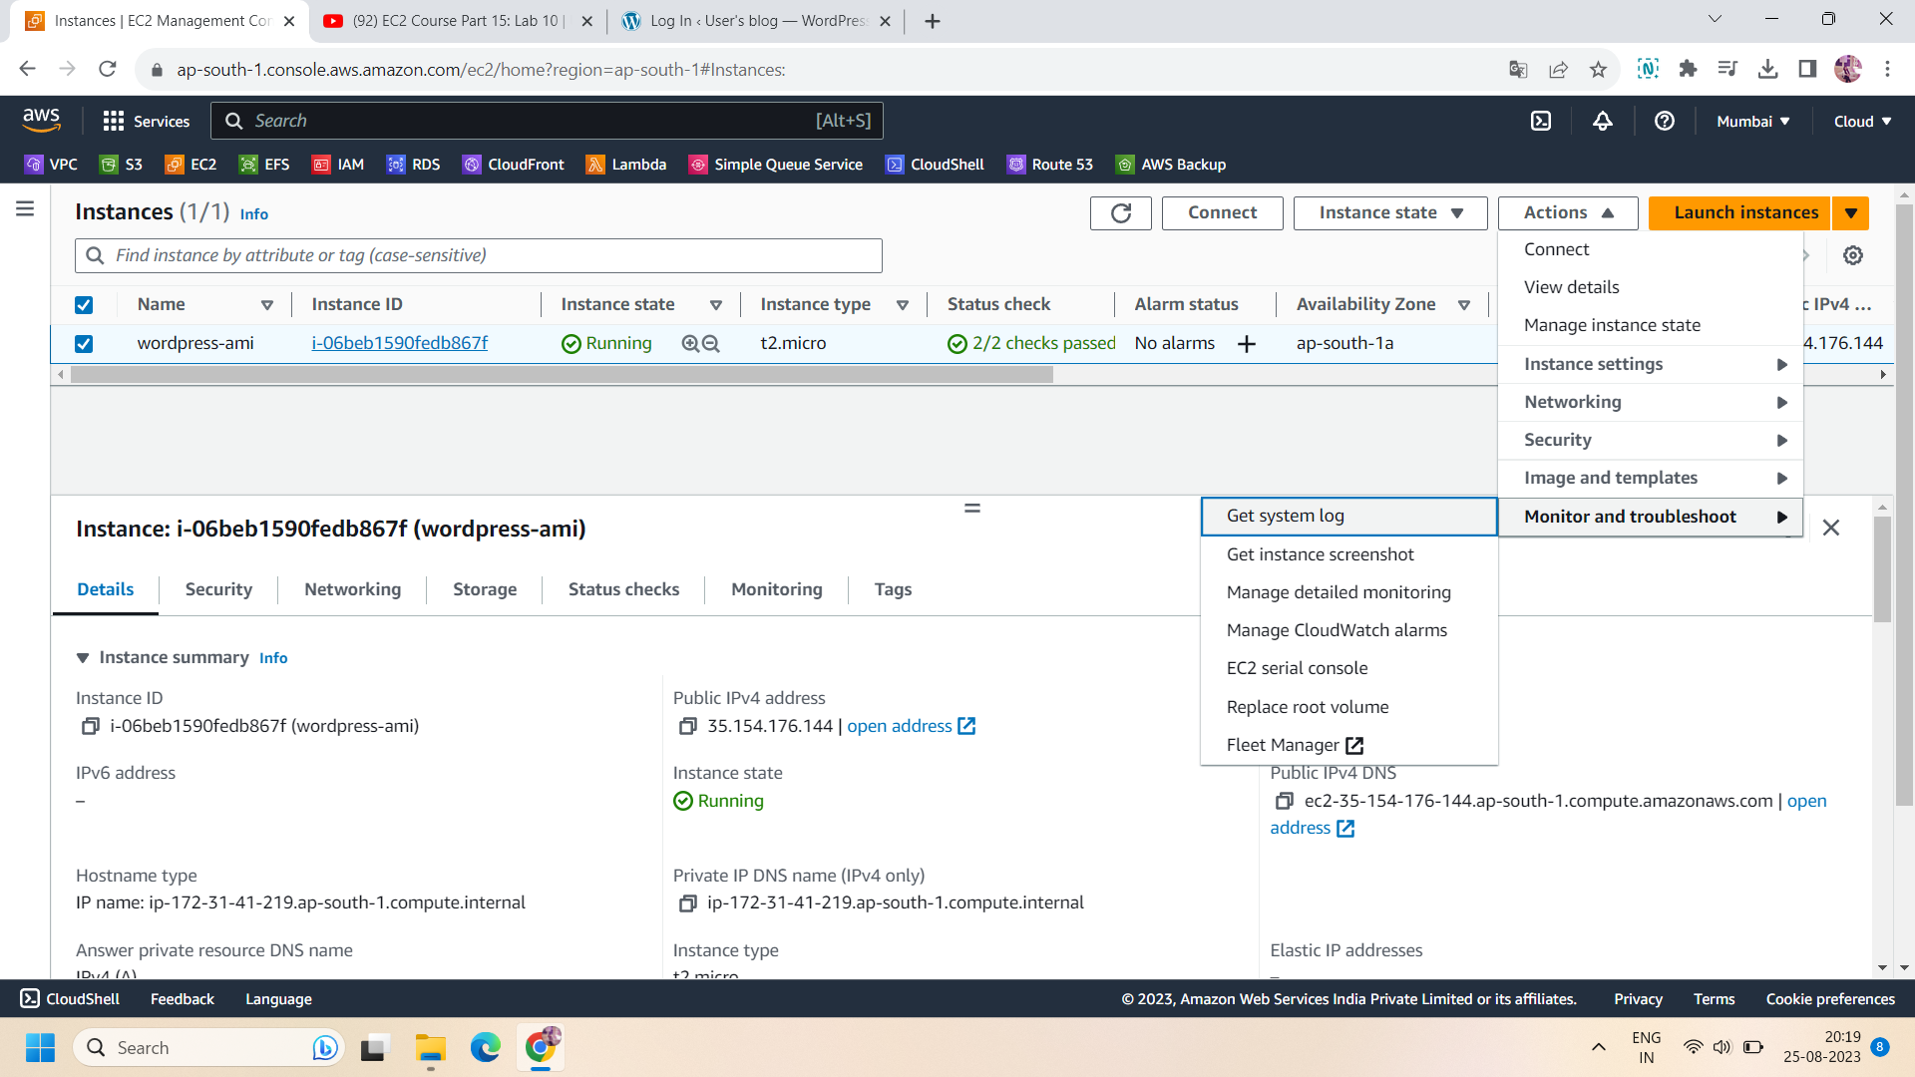

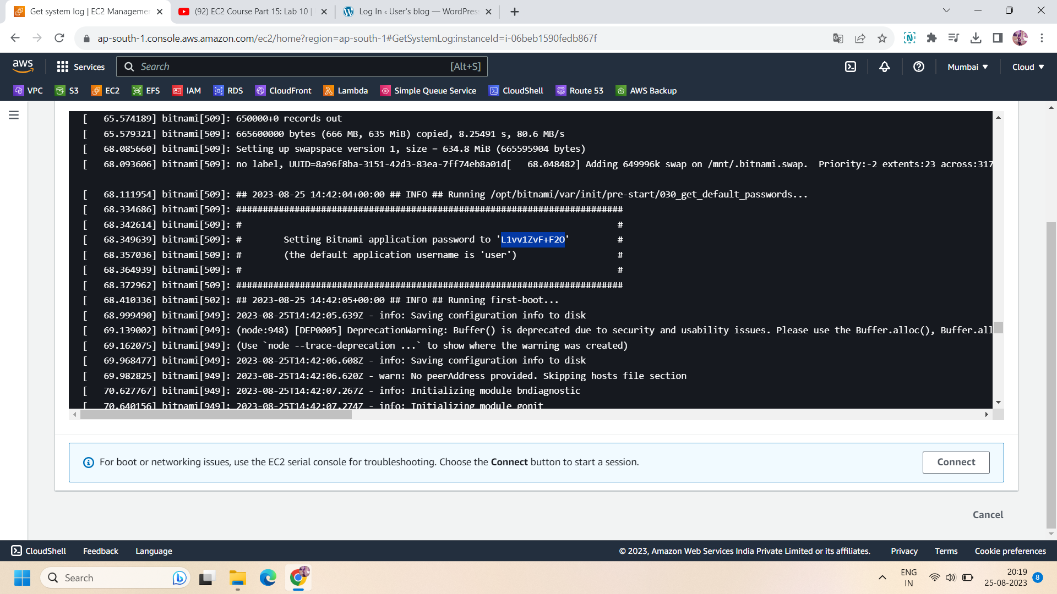

Step 6: Now ,you have access to delete ,modify,create,or update any content on wordpress website.

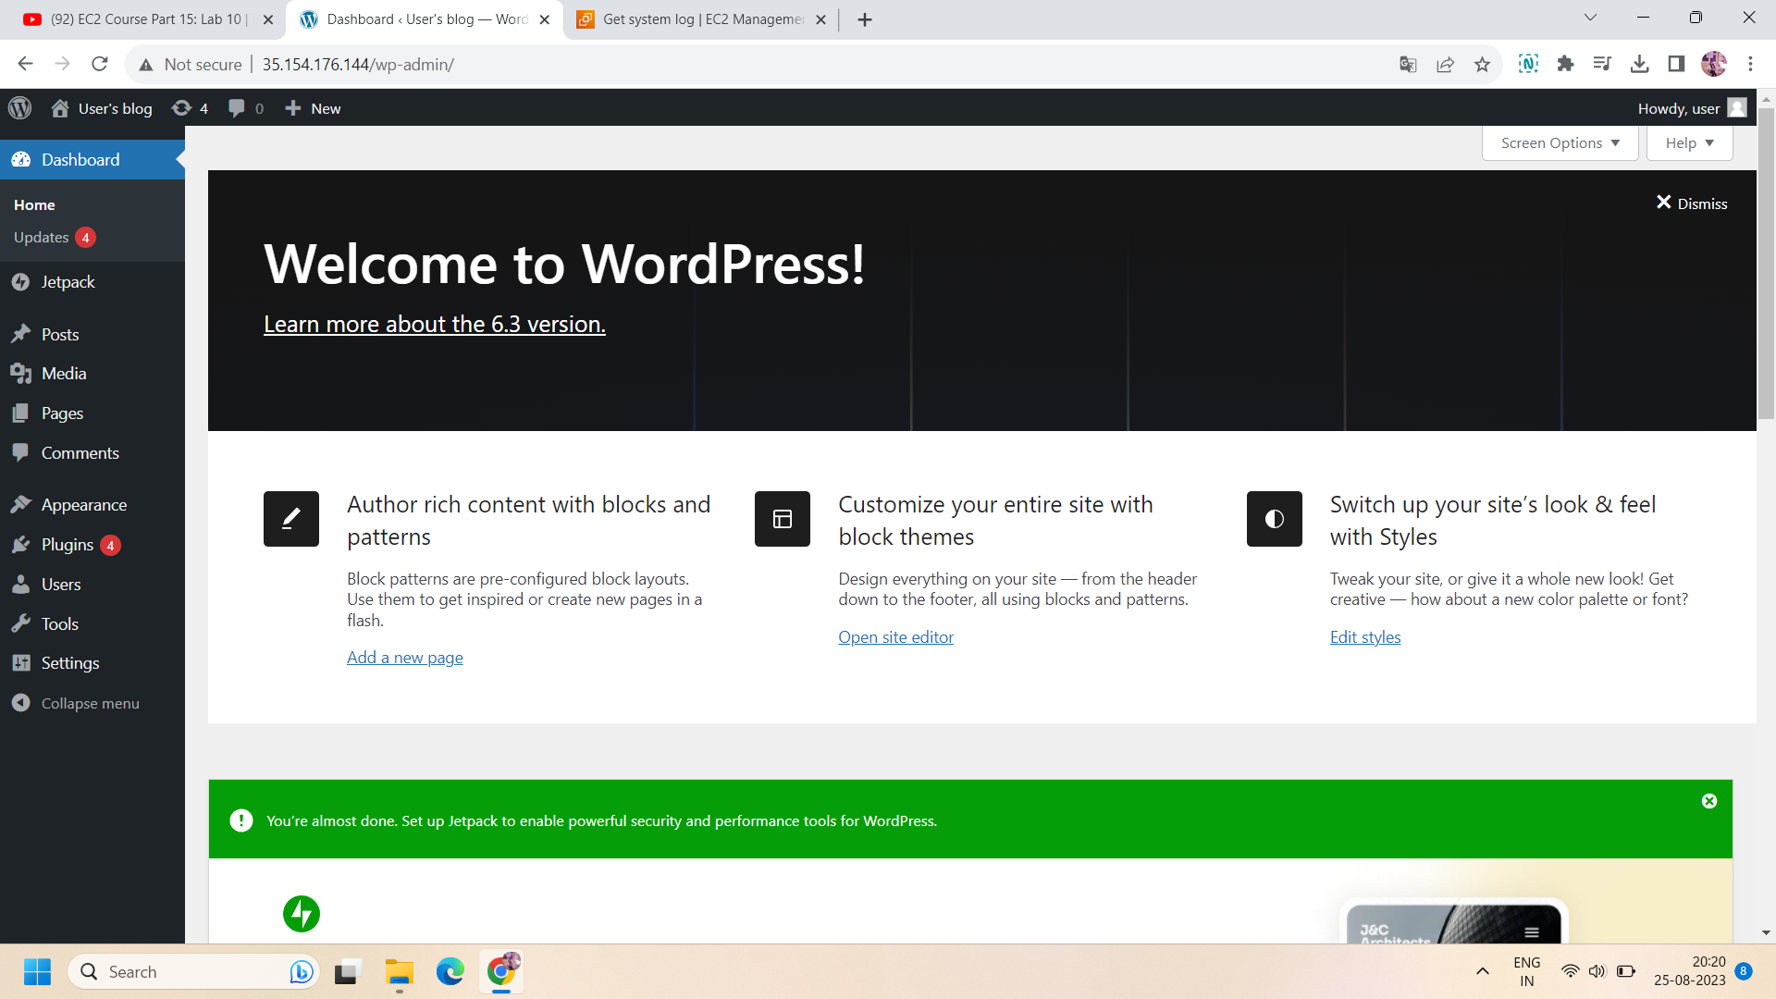

Step 7:for example we want to add a new blog in it.To add ,go to posts and select “add new”.

Then add the title and content for your blog.and click on “Publish”.to open the blog,you can click on “View post” or copy the url of the blog.you will access it.

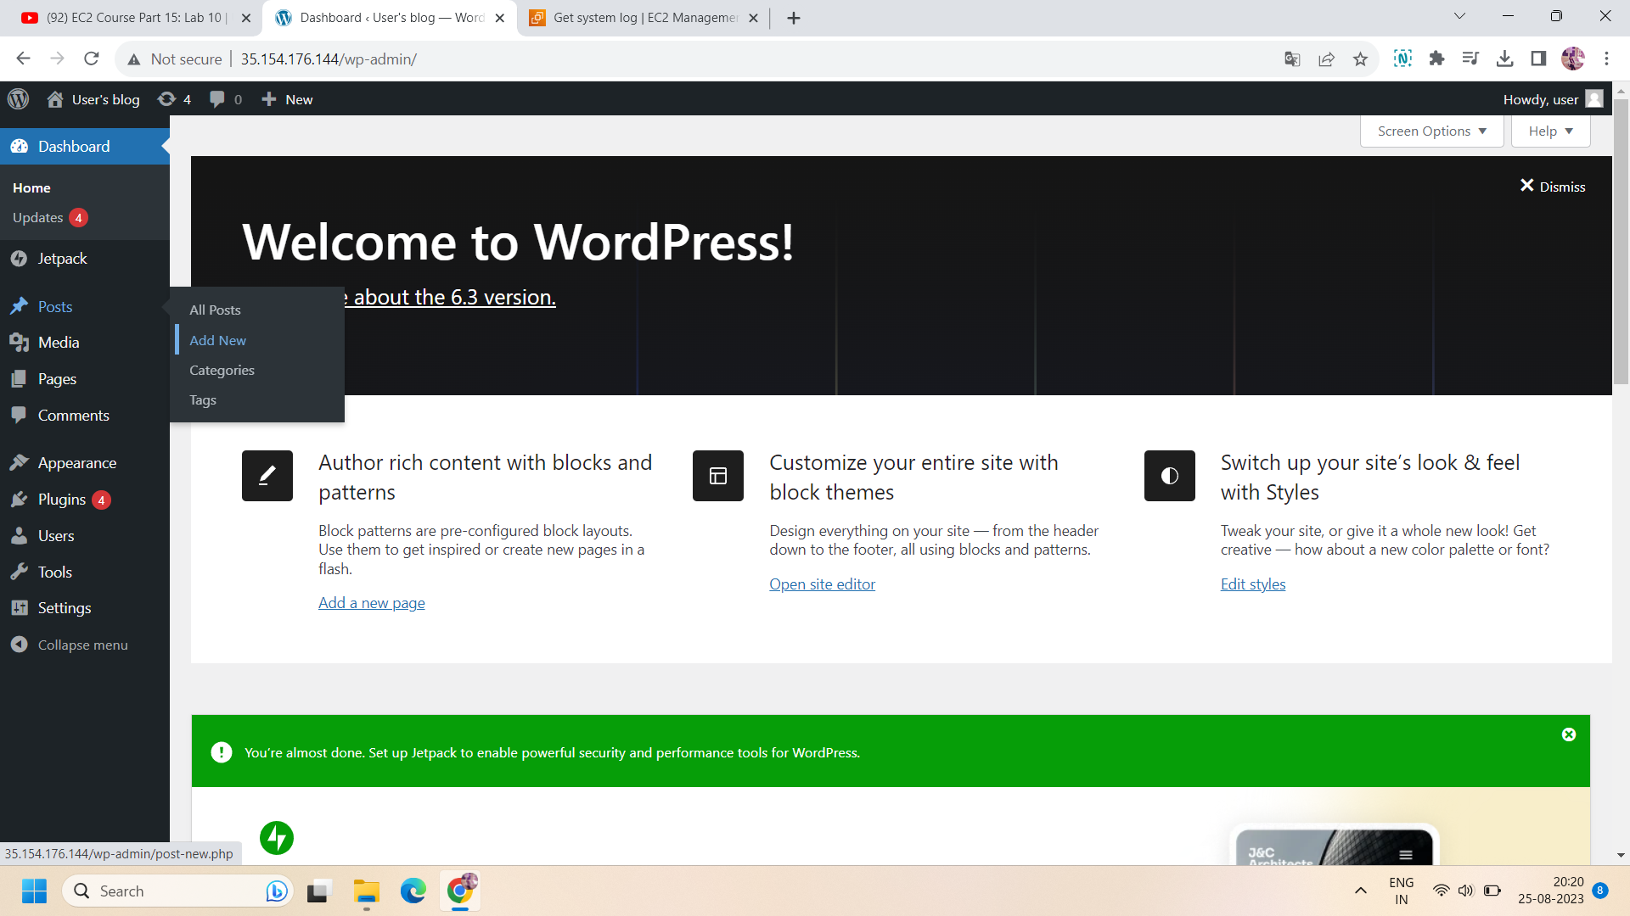

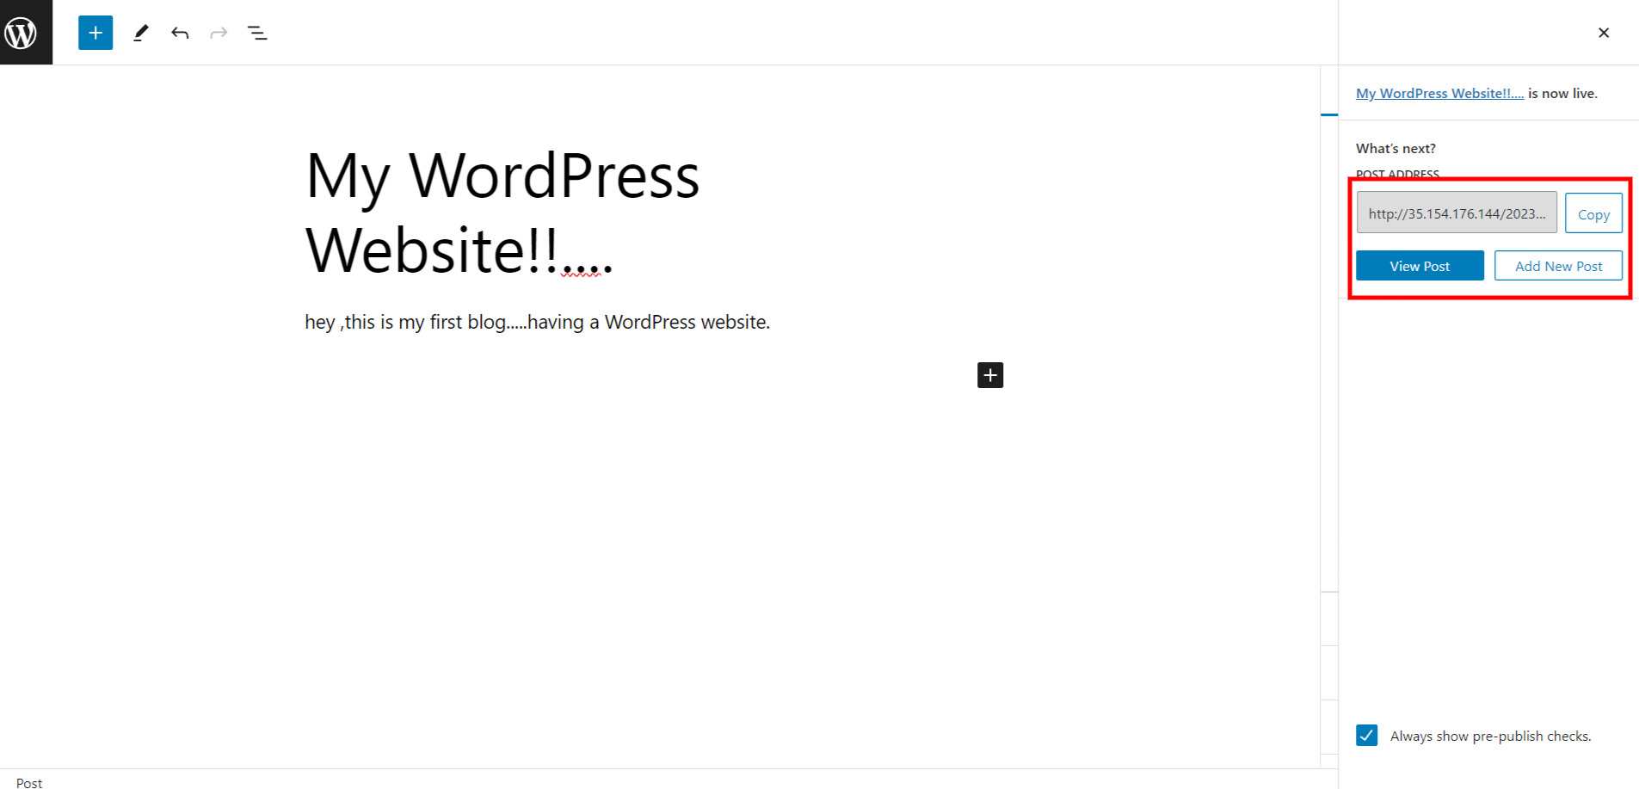

Step 8: so here is the blog look like:

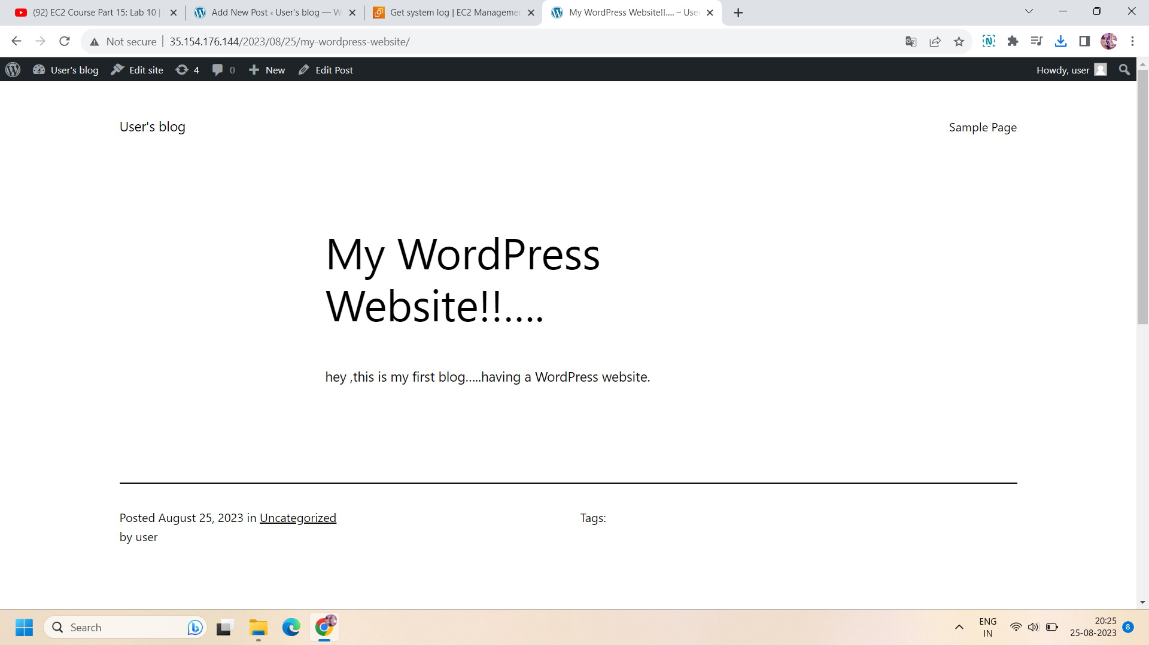

**For backup :**

Step 9: go to volumes and select the volume attached to your wordpress instance,then select the volume and go to actions.in action,click on “create snapshot”.then name the snapshot and click on “create snapshot”.

Step 10: Now ,go to snapshot and select the snapshot created in above step and then go to actions.in action ,click on “create image from snapshot” to create an image of your snapshot.this will create an image and you can access it in “AMI section”.

Step 11: Now ,if you terminate your wordpress instance ,then ami and snapshot of it will be available even after termination of wordpress instance.So to recover the instance ,you can create an instance using the same AMI.

ALL done!!